SRT ® Targets srl

3D and Targets Made in Italy
Via Milano 129 m 22063 Cantù (CO)
Tel./fax +39/031/730828
www.srt-targets.com
SRT ® | Dicembre 2017

Daino Sdraiato melanico

08470892

Gruppo IBO/IFAA 1 WA 1
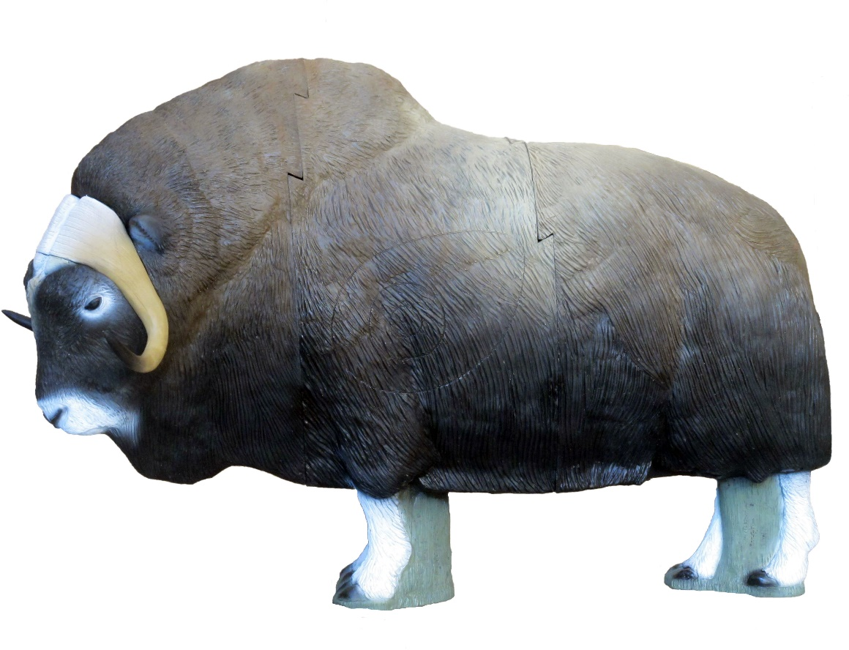

Tecnical Informations :

Target in 4 parts

Number of rings for tournament 2
Height 127 cm
Long 180 cm
Large 50 cm
Weight 82 kg

Position of rings :

1 Spot anatomic front side A 33 cm / B 39 cm /C 16 cm / P 7 cm
1 Spot anatomic back left A 33 cm / B 39 cm /C 16 cm / P 7 cm
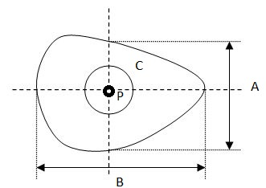

Shipment : 3 boxes on palett,

