SRT ® Targets srl

3D and Targets Made in Italy
Via Milano 129 m 22063 Cantù (CO)
Tel./fax +39/031/730828
www.srt-targets.com
SRT ® | Ottobre 2015

Dodo London 08473348

Gruppo IFAA / IBO 3 / 4

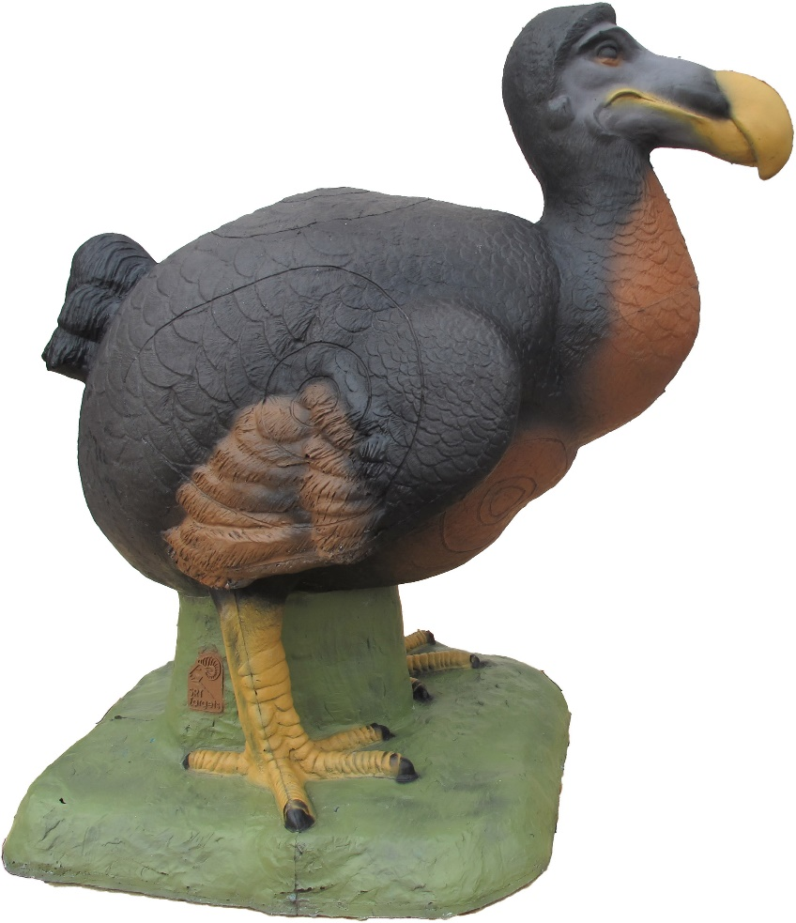

Tecnical Informations :

Number of rings 6
Height 65 cm
Large 65 cm
Weight 8 kg

Position of rings :

2 Spots lateral anatomic 18 ,5 cm /8 cm/ 3,5 cm Group 3
1 Spot back oval 19 cm /8 cm/ 3,3 cm Group 3
2 Spot Front oval 11,8 cm / 5 cm/ 3 cm Group 4
1 Spot Back oval 12 cm / 5 cm/ 3 cm Group 4

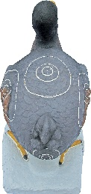 | 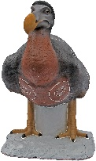 | 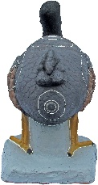 | 