SRT ® Targets srl

3D and Targets Made in Italy
Via Milano 129 m 22063 Cantù (CO)
Tel./fax +39/031/730828
www.srt-targets.com
SRT ® | Maggio 2016

Cinghiale Rosso Red Boar junges Wildschwein

Sanglier rouge Jabalí roja

08471574

Gruppo IFAA / IBO 3 / 4

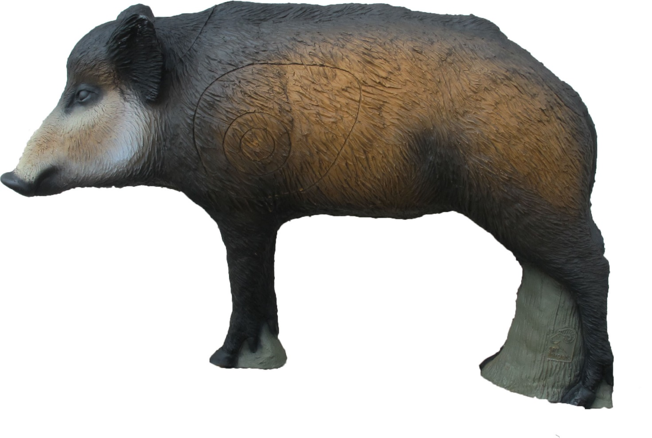

Tecnical Informations :

Number of rings 3
Height 51 cm
Large 78 cm
Weight 8 kg

Position of rings :

2 Spots lateral anatomic 18 ,5 cm h /14 cm/ 4 cm Group 3
1 Spot back oval 14 cm h/ 5,5 cm/ 3,5 cm Group 4

