SRT ® Targets srl

3D and Targets Made in Italy
Via Milano 129 m 22063 Cantù (CO)
Tel./fax +39/031/730828
www.srt-targets.com
SRT ® | Novembre 2015

Tanuki 08472568

Gruppo IFAA / IBO 4

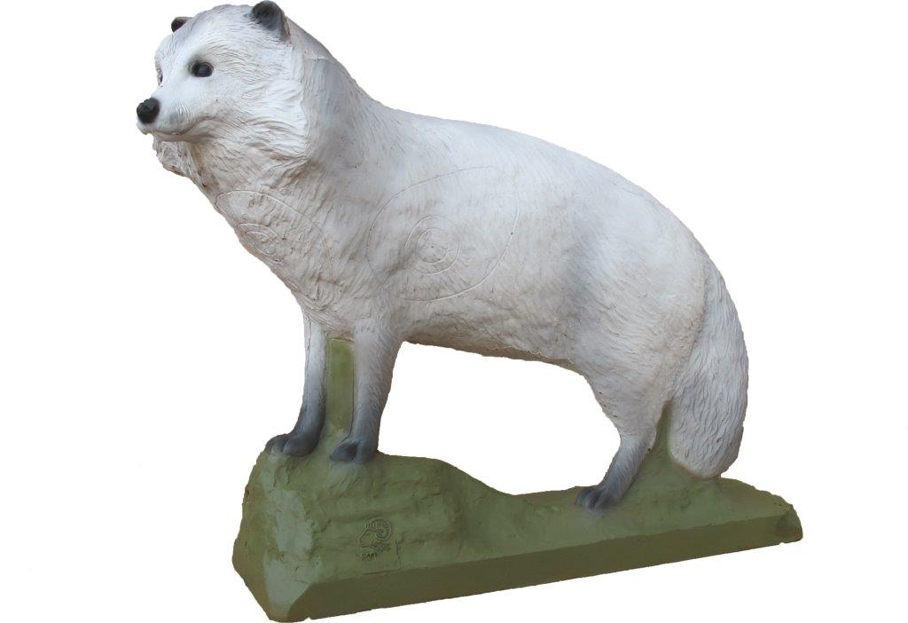

Tecnical Informations :

Number of rings for tourment 5
Height 52 cm
Large 64 cm

Position of rings :

2 rings lateral anatomic 11,5 cm 5 cm 3 cm Group 4
1 ring front anatomic 11 cm 5 cm 3 cm Group 4
1 ring back anatomic 11 cm 5 cm 3 cm Group 4
1 ring neck anatomic 11 cm 5 cm 3 cm Group 4

